Exercise 3: Stored Procedures
Create Table : Accounts
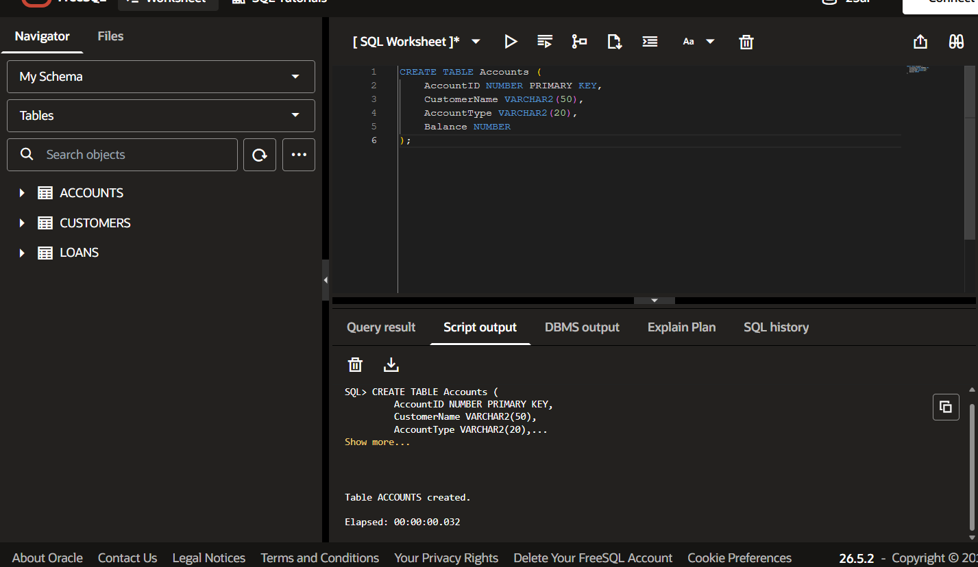
Create Table : Employees
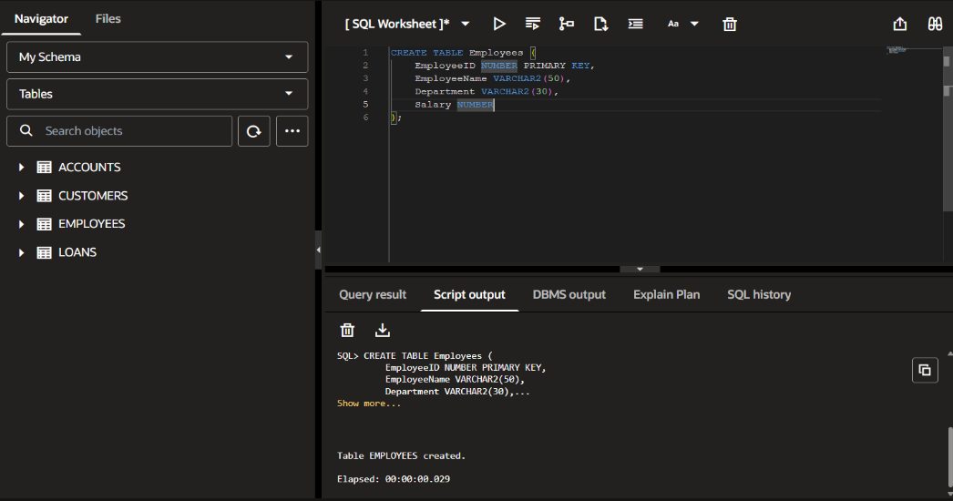
Insert Values
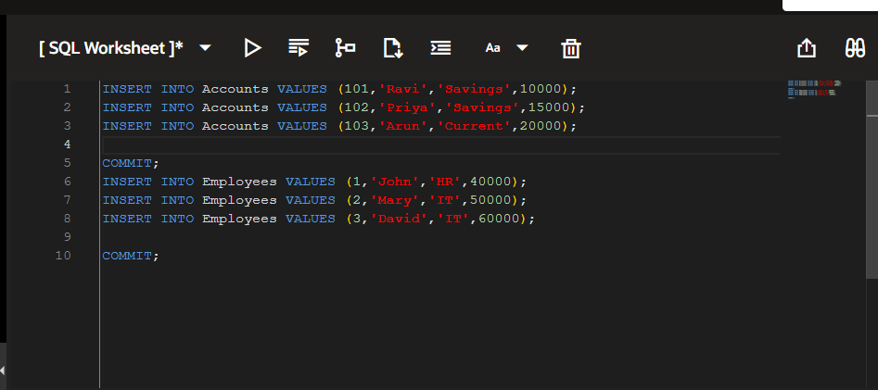
Scenario 1: The bank needs to process monthly interest for all savings accounts.
  - Question: Write a stored procedure ProcessMonthlyInterest that calculates and updates the balance of all savings accounts by applying an interest rate of 1% to the current balance.
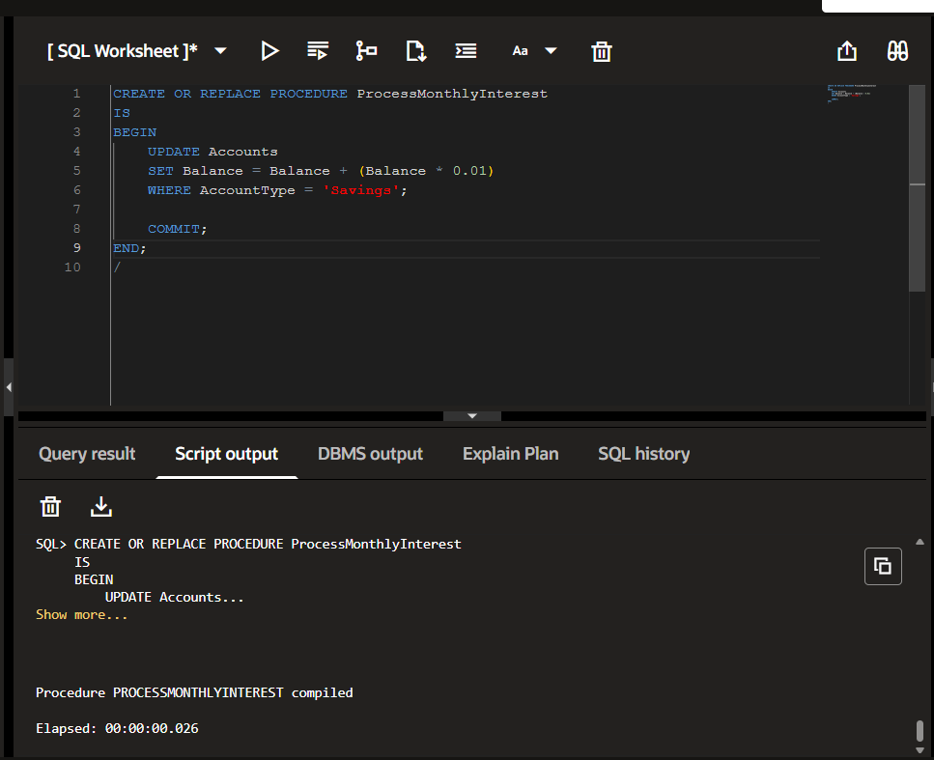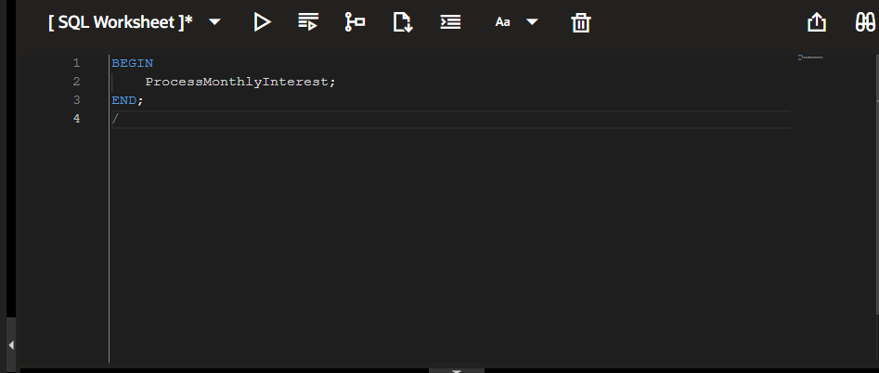
Output:
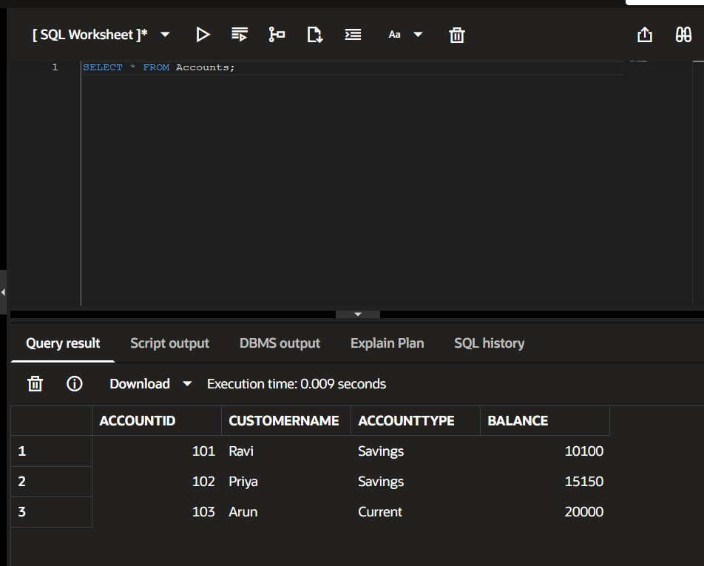

Scenario 2: The bank wants to implement a bonus scheme for employees based on their performance.
  - Question: Write a stored procedure UpdateEmployeeBonus that updates the salary of employees in a given department by adding a bonus percentage passed as a parameter.
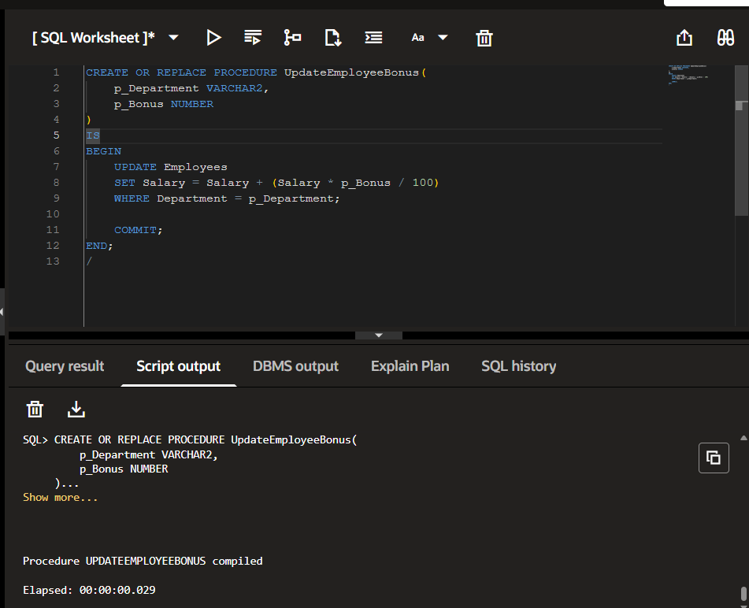
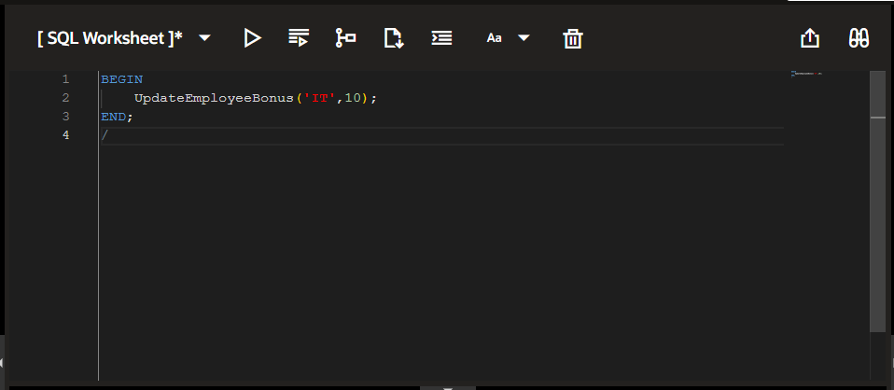
Output :
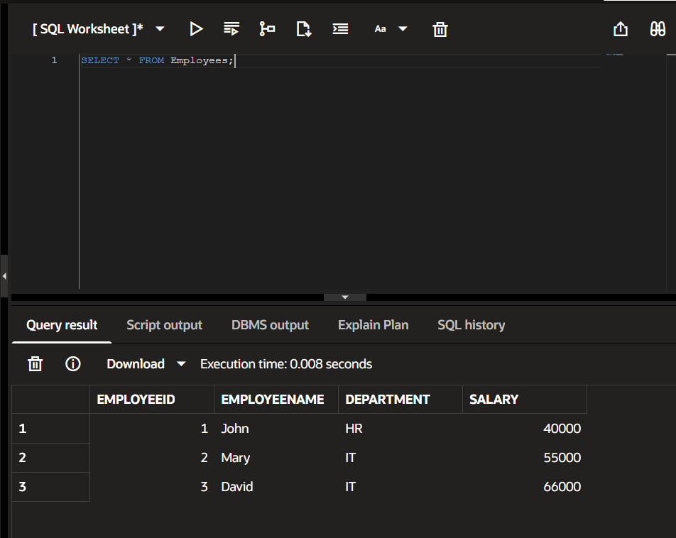

Scenario 3: Customers should be able to transfer funds between their accounts.
  - Question: Write a stored procedure TransferFunds that transfers a specified amount from one account to another, checking that the source account has sufficient balance before making the transfer.
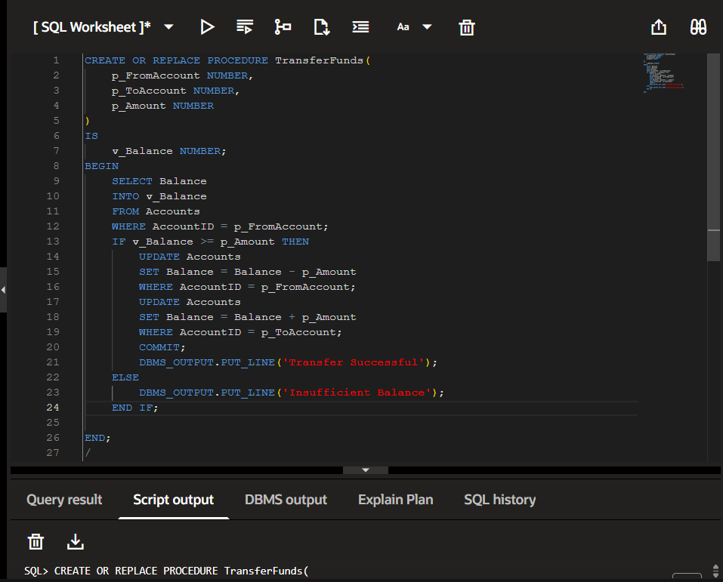
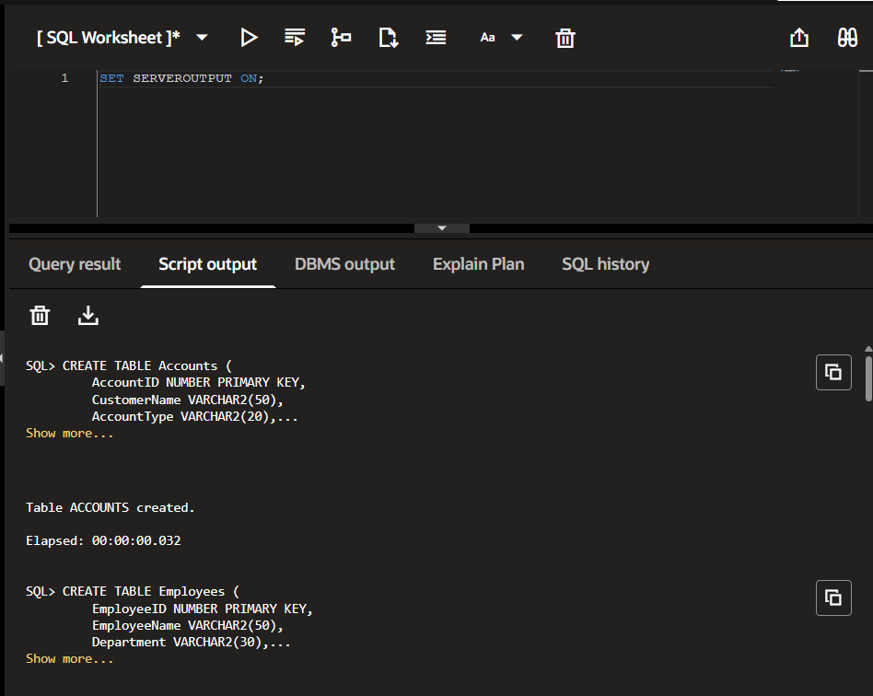
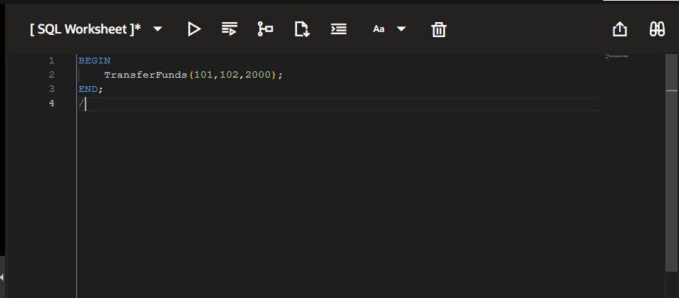

Output:
